Assignment 1
- What regular expressions do you use to extract all the dates in this blurb: http://bit.ly/regexexercise2 and to put them into the following format YYYY-MM-DD ?
https://regex101.com/r/UoeYZm/1 (\d{1,2}).(\d{1,2}).(\s?\d{4})
- Write a regular expression to convert the stopwordlist (list of most frequent Danish words) from Voyant in http://bit.ly/regexexercise3 into a neat stopword list for R (which comprises "words" separated by commas, such as http://bit.ly/regexexercise4 ). Then take the stopwordlist from R http://bit.ly/regexexercise4 and convert it into a Voyant list (words on separate line without interpunction)
https://regex101.com/r/bkQsID/1 \n. Does not work because it gives extra lines in the substitution
https://regex101.com/r/P8bweN/1 "\s*,\s*" But this sorts it without the extra enters in the substitution.
- Does OpenRefine alter the raw data during sorting and filtering?
- No it does not, it gives you some solutions without altering the raw data.
- Fix the interviews dataset in OpenRefine enough to answer this question: "Which two months are reported as the most water-deprived/dryest by the interviewed farmer households?"
Way of doing: value.replace("[","").replace("]","").replace(" ","").replace("'","")
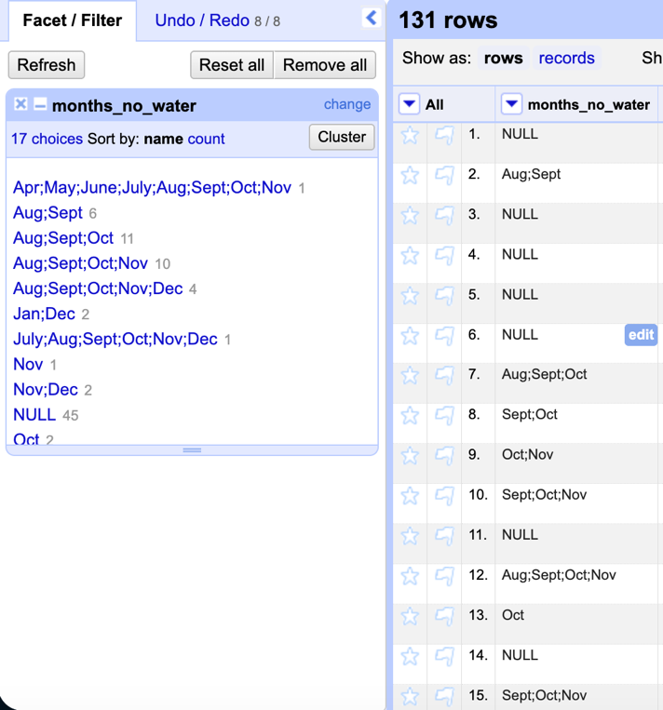
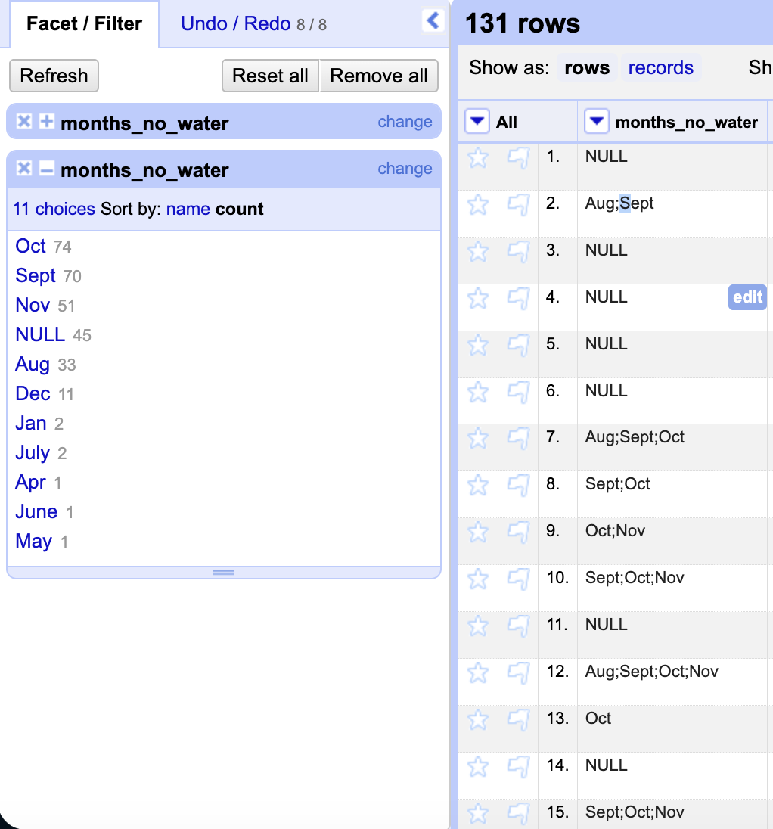
Way of doing: Custom text facet, value.split (”;”)

- Real-Data Challenge: What are the 10 most frequent occupations "erhverv" among unmarried men or women of 20-30 years in 1801 Aarhus census dataset? (hint: first select either men or women to shrink the dataset to a manageable size, then filter by age, and then use merging to cut the erhvervvariation ruthlessly.)
Only include the unmarried:
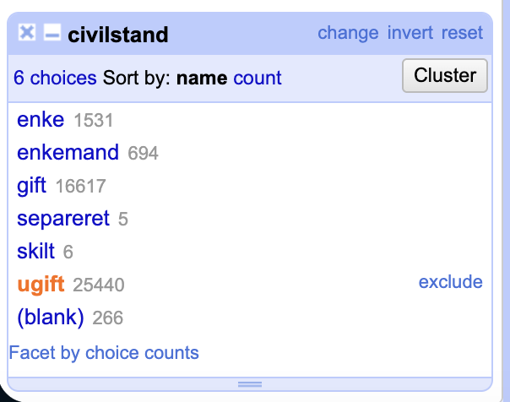
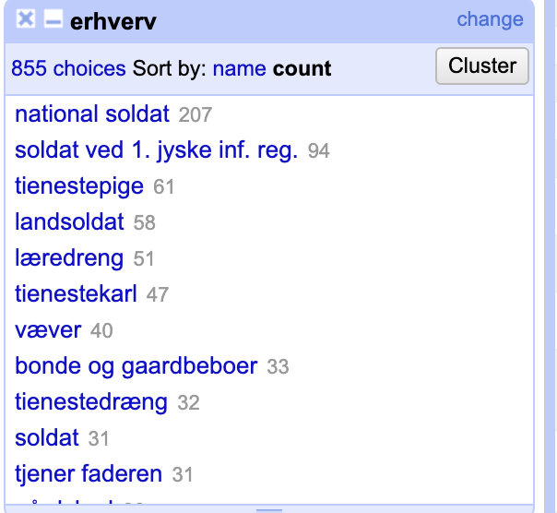
Here you can see the top 10 occupations, there are some of them that are pretty similar like national soldat and landsoldat, but with this method you could find what we were looking for (top 10 jobs).
Cluster, some writing, and then merge.

Attatchments:
For part 4
[
{
"op": "core/text-transform",
"engineConfig": {
"facets": [],
"mode": "row-based"
},
"columnName": "interview_date",
"expression": "value.toDate()",
"onError": "keep-original",
"repeat": false,
"repeatCount": 10,
"description": "Text transform on cells in column interview_date using expression value.toDate()"
},
{
"op": "core/mass-edit",
"engineConfig": {
"facets": [],
"mode": "row-based"
},
"columnName": "village",
"expression": "value",
"edits": [
{
"from": [
"Ruaca",
"Ruca"
],
"fromBlank": false,
"fromError": false,
"to": "Ruaca"
},
{
"from": [
"Ruaca-Nhamuenda",
"Ruaca - Nhamuenda"
],
"fromBlank": false,
"fromError": false,
"to": "Ruaca"
}
],
"description": "Mass edit cells in column village"
},
{
"op": "core/mass-edit",
"engineConfig": {
"facets": [],
"mode": "row-based"
},
"columnName": "village",
"expression": "value",
"edits": [
{
"from": [
"Chirodzo",
"Chirdozo"
],
"fromBlank": false,
"fromError": false,
"to": "Chirodzo"
}
],
"description": "Mass edit cells in column village"
},
{
"op": "core/column-reorder",
"columnNames": [
"interview_date",
"items_owned",
"quest_no",
"start",
"end",
"province",
"district",
"ward",
"village",
"years_farm",
"agr_assoc",
"no_membrs",
"_members_count",
"remittance_money",
"years_liv",
"parents_liv",
"sp_parents_liv",
"grand_liv",
"sp_grand_liv",
"respondent_roof_type",
"respondent_wall_type",
"respondent_wall_type_other",
"respondent_floor_type",
"window_type",
"buildings_in_compound",
"rooms",
"other_buildings",
"no_plots",
"plots_count",
"water_use",
"no_group_count",
"yes_group_count",
"no_enough_water",
"months_no_water",
"period_use",
"exper_other",
"other_meth",
"res_change",
"memb_assoc",
"resp_assoc",
"fees_water",
"affect_conflicts",
"need_money",
"money_source",
"money_source_other",
"crops_contr",
"emply_lab",
"du_labour",
"liv_owned",
"liv_owned_other",
"liv_count",
"poultry",
"du_look_aftr_cows",
"items_owned_other",
"no_meals",
"months_lack_food",
"no_food_mitigation",
"gps_Latitude",
"gps_Longitude",
"gps_Altitude",
"gps_Accuracy",
"instanceID"
],
"description": "Reorder columns"
},
{
"op": "core/text-transform",
"engineConfig": {
"facets": [],
"mode": "row-based"
},
"columnName": "items_owned",
"expression": "grel:value.replace(\" \",\"\").replace(\"[\",\"\").replace(\"'\",\"\").replace(\")\",\"\")",
"onError": "keep-original",
"repeat": false,
"repeatCount": 10,
"description": "Text transform on cells in column items_owned using expression grel:value.replace(\" \",\"\").replace(\"[\",\"\").replace(\"'\",\"\").replace(\")\",\"\")"
},
{
"op": "core/text-transform",
"engineConfig": {
"facets": [],
"mode": "row-based"
},
"columnName": "items_owned",
"expression": "grel:value.replace(\"]\",\"\")",
"onError": "keep-original",
"repeat": false,
"repeatCount": 10,
"description": "Text transform on cells in column items_owned using expression grel:value.replace(\"]\",\"\")"
},
{
"op": "core/column-move",
"columnName": "months_no_water",
"index": 0,
"description": "Move column months_no_water to position 0"
},
{
"op": "core/text-transform",
"engineConfig": {
"facets": [],
"mode": "row-based"
},
"columnName": "months_no_water",
"expression": "grel:value.replace(\"[\",\"\").replace(\"]\",\"\").replace(\" \",\"\").replace(\"'\",\"\")",
"onError": "keep-original",
"repeat": false,
"repeatCount": 10,
"description": "Text transform on cells in column months_no_water using expression grel:value.replace(\"[\",\"\").replace(\"]\",\"\").replace(\" \",\"\").replace(\"'\",\"\")"
}
]

For part 5
[
{
"op": "core/text-transform",
"engineConfig": {
"facets": [
{
"type": "list",
"name": "koen",
"expression": "value",
"columnName": "koen",
"invert": false,
"omitBlank": false,
"omitError": false,
"selection": [
{
"v": {
"v": "kvinde",
"l": "kvinde"
}
}
],
"selectBlank": false,
"selectError": false
},
{
"type": "list",
"name": "civilstand",
"expression": "value",
"columnName": "civilstand",
"invert": false,
"omitBlank": false,
"omitError": false,
"selection": [
{
"v": {
"v": "ugift",
"l": "ugift"
}
}
],
"selectBlank": false,
"selectError": false
}
],
"mode": "row-based"
},
"columnName": "alder",
"expression": "value.toNumber()",
"onError": "keep-original",
"repeat": false,
"repeatCount": 10,
"description": "Text transform on cells in column alder using expression value.toNumber()"
},
{
"op": "core/text-transform",
"engineConfig": {
"facets": [
{
"type": "list",
"name": "koen",
"expression": "value",
"columnName": "koen",
"invert": false,
"omitBlank": false,
"omitError": false,
"selection": [
{
"v": {
"v": "kvinde",
"l": "kvinde"
}
}
],
"selectBlank": false,
"selectError": false
},
{
"type": "list",
"name": "civilstand",
"expression": "value",
"columnName": "civilstand",
"invert": false,
"omitBlank": false,
"omitError": false,
"selection": [
{
"v": {
"v": "ugift",
"l": "ugift"
}
}
],
"selectBlank": false,
"selectError": false
}
],
"mode": "row-based"
},
"columnName": "erhverv",
"expression": "value.toLowercase()",
"onError": "keep-original",
"repeat": false,
"repeatCount": 10,
"description": "Text transform on cells in column erhverv using expression value.toLowercase()"
},
{
"op": "core/text-transform",
"engineConfig": {
"facets": [],
"mode": "row-based"
},
"columnName": "erhverv",
"expression": "value.toLowercase()",
"onError": "keep-original",
"repeat": false,
"repeatCount": 10,
"description": "Text transform on cells in column erhverv using expression value.toLowercase()"
},
{
"op": "core/column-move",
"columnName": "civilstand",
"index": 0,
"description": "Move column civilstand to position 0"
},
{
"op": "core/column-move",
"columnName": "erhverv",
"index": 0,
"description": "Move column erhverv to position 0"
},
{
"op": "core/mass-edit",
"engineConfig": {
"facets": [
{
"type": "list",
"name": "civilstand",
"expression": "value",
"columnName": "civilstand",
"invert": false,
"omitBlank": false,
"omitError": false,
"selection": [
{
"v": {
"v": "ugift",
"l": "ugift"
}
}
],
"selectBlank": false,
"selectError": false
}
],
"mode": "row-based"
},
"columnName": "erhverv",
"expression": "value",
"edits": [
{
"from": [
"nationalsoldat",
"national-soldat"
],
"fromBlank": false,
"fromError": false,
"to": "nationalsoldat"
},
{
"from": [
"inderste, nyder almisse af sognet",
"inderste nyder almisse af sognet"
],
"fromBlank": false,
"fromError": false,
"to": "inderste, nyder almisse af sognet"
},
{
"from": [
"handler med uld og skind, landeværnsmand",
"landeværnsmand, handler med uld og skind"
],
"fromBlank": false,
"fromError": false,
"to": "handler med uld og skind, landeværnsmand"
},
{
"from": [
"land-rytter",
"landrytter"
],
"fromBlank": false,
"fromError": false,
"to": "land-rytter"
},
{
"from": [
"inderste og væverske",
"væverske og inderste"
],
"fromBlank": false,
"fromError": false,
"to": "inderste og væverske"
},
{
"from": [
"skrøbelig og nyder almisse af sognet",
"skrøbelig, og nyder almisse af sognet"
],
"fromBlank": false,
"fromError": false,
"to": "skrøbelig og nyder almisse af sognet"
},
{
"from": [
"huus - jomfrue",
"huus jomfrue"
],
"fromBlank": false,
"fromError": false,
"to": "huus - jomfrue"
},
{
"from": [
"bonde og gårdbeboer",
"gårdbeboer og bonde"
],
"fromBlank": false,
"fromError": false,
"to": "bonde og gårdbeboer"
},
{
"from": [
"landrecrut",
"land-recrut"
],
"fromBlank": false,
"fromError": false,
"to": "landrecrut"
},
{
"from": [
"dum og døv",
"døv og dum"
],
"fromBlank": false,
"fromError": false,
"to": "dum og døv"
},
{
"from": [
"nat: soldat",
"nat. soldat"
],
"fromBlank": false,
"fromError": false,
"to": "nat: soldat"
},
{
"from": [
"landsoldat",
"land-soldat"
],
"fromBlank": false,
"fromError": false,
"to": "landsoldat"
},
{
"from": [
"væverdreng",
"væver-dreng"
],
"fromBlank": false,
"fromError": false,
"to": "væverdreng"
},
{
"from": [
"indsidder og væver",
"væver og indsidder"
],
"fromBlank": false,
"fromError": false,
"to": "indsidder og væver"
},
{
"from": [
"skræderdreng",
"skræder-dreng"
],
"fromBlank": false,
"fromError": false,
"to": "skræderdreng"
},
{
"from": [
"snedker",
"[snedker]"
],
"fromBlank": false,
"fromError": false,
"to": "snedker"
},
{
"from": [
"huusjomfrue",
"huus-jomfrue"
],
"fromBlank": false,
"fromError": false,
"to": "huusjomfrue"
}
],
"description": "Mass edit cells in column erhverv"
},
{
"op": "core/mass-edit",
"engineConfig": {
"facets": [
{
"type": "list",
"name": "civilstand",
"expression": "value",
"columnName": "civilstand",
"invert": false,
"omitBlank": false,
"omitError": false,
"selection": [
{
"v": {
"v": "ugift",
"l": "ugift"
}
}
],
"selectBlank": false,
"selectError": false
}
],
"mode": "row-based"
},
"columnName": "erhverv",
"expression": "value",
"edits": [
{
"from": [
"nationalsoldat"
],
"fromBlank": false,
"fromError": false,
"to": "nationa lsoldat"
}
],
"description": "Mass edit cells in column erhverv"
},
{
"op": "core/mass-edit",
"engineConfig": {
"facets": [
{
"type": "list",
"name": "civilstand",
"expression": "value",
"columnName": "civilstand",
"invert": false,
"omitBlank": false,
"omitError": false,
"selection": [
{
"v": {
"v": "ugift",
"l": "ugift"
}
}
],
"selectBlank": false,
"selectError": false
}
],
"mode": "row-based"
},
"columnName": "erhverv",
"expression": "value",
"edits": [
{
"from": [
"nationa lsoldat"
],
"fromBlank": false,
"fromError": false,
"to": "national soldat"
}
],
"description": "Mass edit cells in column erhverv"
}
]

